

Research Proposal
Combining Classical Rhetorical Theory with State-of-the-Art AI Techniques for Discovering Hidden Tashbīh in Arabic Poetry as a Case Study
Faisal Omari – 325616894
Prof. Tsvi Kuflik, The Department of Information Systems
Prof. Ali Hussein, Department of Arabic Language and Literature

Department of Computer Science
May 2025

Table of Contents
1. Introduction 3
2. Background and Related Work 6
Arabic Language 6
Arabic Poetry 6
Natural language processing (NLP) 6
Arabic NLP – challenges and importance 7
Tashbīh in Arabic Rhetoric 7
Advances in NLP for Arabic 8
Related Work 10
3. Research Goals and Questions 13
Research Questions 13
4. Tools and Methods 14
Overview of the Research Pipeline 14
Tools and Frameworks 16
5. Initial Experiments and Results 18
Dataset and Setup 18
Results 18
Interpretation and Potential 19
6. Planned Research and Future Work 20
7. Contribution 21
Linguistic and Theoretical Contributions 22
Technical and Computational Contributions 22
8. References 24

- Introduction
Arabic poetry is one of the rich literary traditions, deeply intertwined with the culture, language, and identity of the Arab people. Within this poetic heritage, tashbīh (تشبيه), or simile, stands out as a central rhetorical device, used to create vivid imagery, evoke emotions, and clarify abstract concepts. Traditionally, tashbīh is expressed through explicit linguistic markers such as “كأن” (as if), “مثل” (like), or “كما” (as). For instance, the poet may write: "كأنّ سيوفهم نجومٌ في الليلة الظلماء" "As if their swords were stars in the dark night."
In this line, the simile is clearly marked by the word “كأنّ” and draws a comparison between swords and stars, emphasizing their brilliance and sharpness.
However, beyond these overt constructions lies a subtler and more complex form of rhetorical expression— which is called tashbīh balīgh (implicit simile). These similes lack explicit comparison words, yet they maintain the poetic function of comparison. For example, a poet may say:
"سيوفهم نجوم في الليل" "Their swords are stars in the night"
While the line does not include a formal simile particle, the imagery implicitly evokes the same comparison to stars. These hidden similes are more difficult to detect, both for readers and for computational methods, as they require semantic and contextual understanding rather than keyword spotting.
Previous work on Arabic rhetoric, including research conducted on the Arabic Poetry Corpus developed at the University of Haifa, has focused on detecting explicit tashbīh using rule-based approaches—typically via handcrafted if-else conditions that look for tashbīh markers in poems. This method, while useful, is limited to only surface-level structures and fails to capture deeper, implicit rhetorical meanings.
This thesis aims to take a step forward by addressing the detection of implicit tashbīh using artificial intelligence. We propose to build machine learning models—specifically natural language processing (NLP) models fine-tuned on large pre-trained Arabic transformers such as AraBERT—that are capable of learning what makes a poem “contain tashbīh,” even when the tashbīh is not explicitly marked.
In the initial phase of this research, we have:
- Converted the legacy Java-based rule system to Python for scalability and integration with modern NLP pipelines.
- Used the existing rule-based output to generate a binary labeled dataset of poems with and without tashbīh word.
- Preprocessed the poems by removing diacritics and cleaning the text.
- Fine-tuned the AraBERT model on this dataset, achieving a 96% accuracy in identifying tashbīh poems.
This result demonstrates the feasibility of training models to identify the rhetorical role of tashbīh in classical Arabic poetry.
The next challenge, and the core focus of this thesis, is to move from detecting obvious tashbīh to identifying hidden tashbīh: poetic lines where the comparison is embedded within context and meaning rather than structure. Our long-term goal is to build a model capable of identifying rhetorical richness in Arabic poetry even when surface cues are missing. To this end, we plan to:
- Manually transform a sample of explicit tashbīh poems into hidden ones (29265 poems).
- Investigate what features distinguish hidden tashbīh from non-tashbīh lines.
- Train and evaluate models that can generalize to these deeper forms of rhetorical expression.
Ultimately, this research contributes to the field of digital Arabic literary analysis by combining classical rhetorical theory with state-of-the-art AI techniques, opening new avenues for understanding and interpreting the depth of Arabic poetic language.
Furthermore, the methodological framework developed in this work—particularly the approach to identifying implicit similes—can potentially be adapted to other languages and literary traditions, laying the foundation for broader cross-linguistic applications of rhetorical detection in computational literature studies.
- Background and Related Work

Arabic Language
Arabic is a Semitic language characterized by rich morphology, complex syntactic structures, and deep-rooted rhetorical traditions [1][2]. It features a templatic root-and-pattern system, where most words are derived from triliteral roots, enabling high lexical productivity [3]. Arabic is also diglossic, with a significant difference between Modern Standard Arabic (MSA) and its spoken dialects, adding another layer of linguistic complexity [4][5].

Arabic Poetry
Arabic poetry, particularly pre-modern and classical forms, is a core cultural and literary heritage in the Arab world. Poems are rich in rhetorical devices, emotional depth, and symbolic expression. They are written in a highly stylized and metrically constrained form, which enhances their expressive power but also introduces challenges for computational analysis due to non-standard grammar and poetic licenses [6].

Natural language processing (NLP)
Natural Language Processing (NLP) is a subfield of artificial intelligence (AI) that focuses on enabling computers to understand, interpret, generate, and manipulate human language. It lies at the intersection of linguistics and computer science and plays a critical role in applications such as machine translation, sentiment analysis, speech recognition, chatbots, question answering systems, and text classification [7]. NLP systems rely on a combination of rule-based algorithms, statistical methods, and machine learning techniques—particularly deep learning models—to process language at different levels, from word morphology and syntax to semantic understanding and discourse analysis [8]. With the advent of transformer-based models like BERT and GPT, NLP has achieved significant advances in performance, bringing machines closer to understanding the nuances, ambiguity, and complexity of human communication. As such, NLP serves not only as a technical tool but also as a bridge between computational power and human expression [9].

Arabic NLP – challenges and importance
Natural Language Processing (NLP) in Arabic faces several unique challenges [10]:
- Morphological richness: A single Arabic word may encode extensive grammatical information (e.g., gender, number, tense), leading to data sparsity and ambiguity.
- Orthographic ambiguity: Arabic script lacks short vowels (diacritics) in most modern texts, causing lexical and syntactic ambiguities.
- Tokenization issues: Clitics (e.g., prepositions, conjunctions, articles) often attach to words, making segmentation non-trivial.
- Lack of high-quality labeled data: Compared to English, Arabic has fewer publicly available, large-scale annotated corpora for complex NLP tasks.
Despite the challenges, Arabic NLP is a rich and underexplored field with high cultural, academic, and technological value. It offers opportunities for preserving literary heritage, enabling cross-linguistic computational research, and empowering Arabic-speaking communities with advanced AI tools [10]. Rhetorical structures like tashbīh, metaphor (including personification) are deeply embedded in Arabic expression, making their computational study both intellectually rewarding and practically useful for applications in education, search, and cultural preservation [2].

Tashbīh in Arabic Rhetoric
Arabic rhetoric (balāgha) treats tashbīh (simile) as a foundational stylistic device. It is used to compare two entities by highlighting a shared attribute. The components of a classical simile are [11]:
1) mushabbah (Tenor; i.e., the object being compared)
2) mushabbah bihi (Vehicle; i.e., the object to which it is compared)
3) wajh al-shabah (the point of similarity)
4) the simile particle (e.g., كأن، مثل، كما).
• Explicit similes (tashbīh muṣarraḥ mursal) include the simile particle. When all four components of a simile—vehicle, tenor, particle, and point of similarity—are present, the simile is called tashbīh tāmm (complete simile). For example: 'Zayd is like a lion in bravery.' [11].
• Implicit simile (tashbīh muʾakkad) omits the simile particle and relies on context to imply similarity. For example, a poet might say: 'He is a lion in battle', implying courage without the word 'like' [12].
• Classical rhetoricians and lexicographers elaborated on various types of simile and their rhetorical effects [13][14].

Advances in NLP for Arabic
Recent Arabic NLP has benefited from large-scale pre-trained models such as AraBERT. These models can capture contextual nuances and semantic relationships, offering promise for detecting hidden similes [15].
In English NLP, similar challenges have been addressed through transformer-based models for metaphor and figurative language detection, such as DeepMet and MelBERT [16]. These models leverage contextual embeddings to capture nuanced semantic relationships that go beyond surface-level word usage. Their success in identifying implicit metaphors in English prose suggests that similar architectures are well-suited for handling the complexity and subtlety of Arabic poetic expressions [17]. This relevance stems from the shared need to interpret figurative meaning, handle syntactic variation, and model context-dependent rhetoric—core challenges in both languages [16][17].
Detailed Overview of Arabic NLP Tools for Morphological Analysis:
• AlKhalil Morpho Sys 2: This is a robust Arabic morphological analyzer developed to handle both vocalized and unvocalized text. It uses a large internal lexicon and a set of rules to provide information such as the root, pattern, POS tags, and affixes of Arabic words. Pros: High accuracy on Classical Arabic; extensive lexicon coverage. Cons: Performance may degrade with dialectal or modern informal texts [18].
• MADAMIRA: An evolution of MADA and AMIRA, MADAMIRA is a Java-based tool offering tokenization, POS tagging, lemmatization, and diacritization. It is optimized for Modern Standard Arabic and provides a user-friendly interface with both batch and web modes. Pros: Fast, comprehensive, and widely used in academic NLP projects. Cons: Less effective for historical or poetic texts where language is highly figurative or archaic [19].
• BAMA (Buckwalter Arabic Morphological Analyzer): This was one of the earliest tools for analyzing Arabic morphology. It provides possible morphological analyses for Arabic words based on a large dictionary of stems and affixes. Pros: Fundamental and influential in early Arabic NLP research. Cons: Generates many ambiguous outputs and lacks disambiguation capabilities; limited support for contextual inference [20].
• SAMA (Standard Arabic Morphological Analyzer): An improved version of BAMA developed by the Linguistic Data Consortium. It refines and expands the analysis with updated lexicons and additional grammatical coverage. Pros: Better performance than BAMA and integrated in many academic projects. Cons: Still suffers from ambiguity and requires external tools for disambiguation [21].
• Farasa: A fast and efficient Arabic segmentation and POS tagging tool designed especially for processing large-scale data quickly. Pros: Speed and scalability; good for real-time applications. Cons: Less accurate in deeper morphological analysis compared to tools like MADAMIRA or AlKhalil [22].
• AMIRA: A tool for Arabic tokenization and base phrase chunking, offering rapid POS tagging with reasonably high accuracy. Pros: Lightweight and good for simple NLP pipelines. Cons: Outperformed by MADAMIRA and lacks support for complex morphological tasks [23].

Related Work
The Arabic Rhetoric Identifier (REI), developed at the University of Haifa, is a rule-based system for detecting rhetorical devices in Arabic poetry, including tashbīh. It uses explicit pattern-matching rules combined with NLP tools [24]. The system operates on a large Arabic Poetry Corpus containing over 29,000 poems spanning 10 centuries. Only a subset of this corpus has been manually annotated due to the complexity of rhetorical analysis [25]. The rule-based approaches struggle with detecting implicit tashbīh due to their reliance on explicit markers. They require constant rule updates and are unable to generalize well to creative or indirect comparisons [24][26].
Belinkov and Glass [27] analyze the application of deep learning techniques to Arabic natural language processing, focusing on the challenges introduced by Arabic’s morphological complexity and orthographic variability. Their study explores how segmentation strategies—such as tokenization, affix separation, and normalization—affect model performance across various NLP tasks. They highlight the impact of diglossia and the difficulty in capturing semantic context when dealing with inflected forms, which often results in sparse data representations. The authors stresses the importance of careful pre-processing and morphological analysis to improve deep learning model outcomes when working with Arabic texts [27].
Abdul-Raof Hussein [2] provides a comprehensive rhetorical and pragmatic analysis of tashbīh in Arabic, distinguishing it from other figurative devices through a structured framework. His work outlines the four components of tashbīh —the likened-to (al-mushabbah), the likened (al-mushabbah bihi), the tashbīh feature, and the tashbīh element—and classifies different types such as implicit, reverse, compound, and imaginary forms. He emphasizes the rhetorical power of succinct and stylistically elevated expressions, especially those that omit explicit comparison markers. This typology not only deepens the understanding of tashbīh in classical Arabic discourse but also serves as a valuable reference for formulating linguistic rules to support automated tashbīh detection in poetry [2].
Ibrahim and Elghazaly [28] proposed a hybrid Arabic text summarization model that combines Rhetorical Structure Theory (RST) [29] with the Vector Space Model (VSM) [30] to enhance semantic extraction and paragraph ranking. The first component of their model applies RST to segment text and identify rhetorical relationships (e.g., justification, contrast), classifying text units as nucleus or satellite. The second component uses cosine similarity in a vector space representation to rank and refine the most relevant segments. Their evaluation of Arabic news articles showed a precision improvement from 56.3% using RST alone to 71.6% using the hybrid method. This work demonstrates the value of rhetorical analysis and cue-based segmentation in Arabic NLP tasks, which can be informative for constructing linguistically aware models in poetic analysis [28].
Khan and Rahman [31] conducted a large-scale comparative study between Quranic verses and pre-Islamic Arabic poetry using modern NLP methods. They applied CAMeLBERT-based embeddings and clustering algorithms to analyze semantic and stylistic patterns across over 10,000 Quranic sentences and 38,000 poetic verses. Their results show that even the most poetic Quranic verses (Makki) form distinct clusters from classical Arabic poetry, supporting the claim of the Quran’s rhetorical uniqueness. This work provides computational evidence for a long-standing debate and highlights the power of embedding-based analysis in modeling Classical Arabic texts. The clustering-based methodology may also inspire future tasks in Arabic literary analysis, such as distinguishing rhetorical devices like tashbīh, and could inform the design of machine learning pipelines for identifying implicit structures in poetry [31].

- Research Goals and Questions
The central goal of this research is to develop, demonstrate, and evaluate automatic methods for identifying implicit tashbīh in classical Arabic poetry. This task lies at the intersection of classical Arabic rhetoric and modern natural language processing (NLP), aiming to bridge centuries-old poetic tradition with contemporary computational techniques.

Research Questions
The proposed research seeks to answer the following key questions:
- RQ1: How can machine learning models accurately identify tashbīh in Arabic poetry beyond rule-based lexical pattern matching?
To address the above research question, we will address the following questions
- RQ1.1: What are the linguistic and semantic characteristics that distinguish implicit tashbīh from other poetic statements such as metaphors?
- RQ1.2: How effective is a transformation-based method in creating high-quality examples of implicit tashbīh for training data augmentation?
- RQ1,3: To what extent can contextual language models like AraBERT generalize to detect implicit rhetorical devices in highly stylized, classical Arabic text?
- RQ1.4: What are the limitations and challenges in modeling deep figurative meaning computationally in the context of Arabic rhetoric?

- Tools and Methods
This section outlines the methodological approach and computational tools used to achieve the research goals of identifying implicit tashbīh in Arabic poetry. The methodology integrates rule-based extraction, data preprocessing, model fine-tuning, and evaluative analysis, all grounded in the principles of Arabic rhetoric and modern NLP.

Overview of the Research Pipeline
The research pipeline consists of the following stages:
- Initial Rule-Based Detection of Tashbīh:
  - A rule-based system (converted from prior Java code to Python) was employed to detect explicit tashbīh in classical Arabic poems.
  - These rules searched for explicit simile particles (e.g., كأن، مثل، كما، كـ) and comparison-related verbs (e.g., شبه، ظن، خال) to identify overt similes.
- Dataset Construction and Labeling:
  - Based on the output of the rule-based detection, a binary-labeled dataset was built poems with tashbīh vs. poems without tashbīh.
  - Manual verification was conducted to ensure quality and correctness, especially for edge cases.
- Text Cleaning and Preprocessing:
  - Diacritics (harakāt) was removed for consistency.
  - Poems were normalized (e.g., converting "ى" to "ي", removing punctuation).
  - Tokenization was applied using tools such as Farasa and MADAMIRA for further segmentation and linguistic analysis.
- Model Training Using AraBERT:
  - The cleaned and labeled dataset was used to fine-tune AraBERT, a transformer-based model pre-trained on large Arabic corpora.
  - A subset of poems was used for training, while the rest (over 28,000 poems) served as a test set.
  - The fine-tuned classifier achieved around 96% accuracy, suggesting strong discriminative power in identifying tashbīh-laden verses.
- Linguistic Guidance on Implicit Similes:
  - In collaboration with experts from the Arabic Language Department at the University of Haifa, a focused analysis was conducted to identify the key linguistic and semantic features that distinguish implicit tashbīh from metaphors and literal statements.
  - The results of this collaboration helped define annotation criteria and guided the construction of a labeled dataset for further modeling.
- Implicit Tashbīh Generation and Classification:
  - An automatically process will be used to convert explicit tashbīh into implicit forms, removing the simile particle while preserving meaning and rhetorical impact.
  - These transformed examples were added to the dataset to train a second model focused on detecting implicit tashbīh.
  - Feature extraction involved semantic embeddings, syntactic patterns, and context windows.
- Evaluation and Error Analysis:
  - The model was evaluated using metrics such as accuracy, precision, recall, F1-score, and confusion matrix.
  - Special attention was given to false positives and false negatives to analyze whether the model captured the poetic simile beyond surface-level cues.

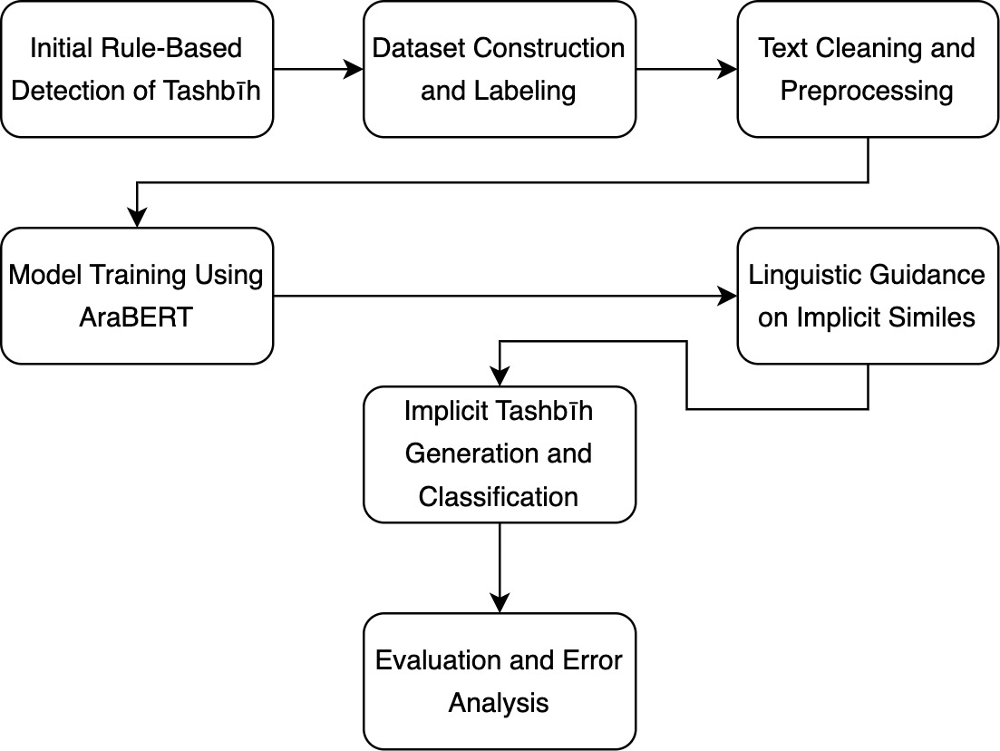

Tools and Frameworks
Several key tools and libraries are employed in this research:
- AlKhalil Morpho Sys 2: For root extraction, morphological analysis, and POS tagging on classical Arabic poetry.
Strength: Excellent performance on vocalized/unvocalized classical texts.
Weakness: Limited support for dialectal or informal Arabic.
- MADAMIRA: A comprehensive tool for morphological disambiguation and tokenization of Modern Standard Arabic.
Strength: Integrates multiple preprocessing steps into a unified tool.
Weakness: Less robust on non-standard poetic constructions.
- Farasa: Lightweight Arabic segmenter and POS tagger, useful for fast preprocessing.
Strength: High speed, scalable.
Weakness: Lower precision in classical or rhetorical contexts.
- BAMA & SAMA: Classical tools from the Linguistic Data Consortium for Arabic morphological analysis.
Strength: Foundational systems with wide lexical coverage.
Weakness: Lack of disambiguation and contextual awareness.
- AraBERT: A deep transformer-based model pre-trained on Arabic corpora.
Strength: Strong contextual understanding, suitable for nuanced NLP tasks.
Weakness: Requires careful fine-tuning and large GPU resources.
- scikit-learn & PyTorch: Used for training, evaluating, and visualizing model outputs and confusion matrices.

- Initial Experiments and Results
The initial experiments focused on evaluating the performance of a fine-tuned AraBERT model in classifying Arabic poems into two categories: poems that contain tashbīh and those that do not.

Dataset and Setup
- The dataset was constructed by applying a rule-based detection system to label Arabic poems as containing tashbīh or not.
- From the full dataset, only 5% of the data was used for training, while the remaining 95% was split for validation and testing
- This small training set was chosen due to the large size of the dataset and the high computational cost of training transformer-based models like AraBERT.
- Despite using only, a small fraction of the data for training, the model achieved high performance, indicating the strength of contextual embeddings in Arabic NLP.

Results
The model’s performance on the test set was evaluated using standard classification metrics:
- Accuracy: 95.71%
- Precision: 95.46%
- Recall: 95.99%
These scores show that the model is highly reliable in distinguishing between simile and non-simile poetry lines, even with limited training data.
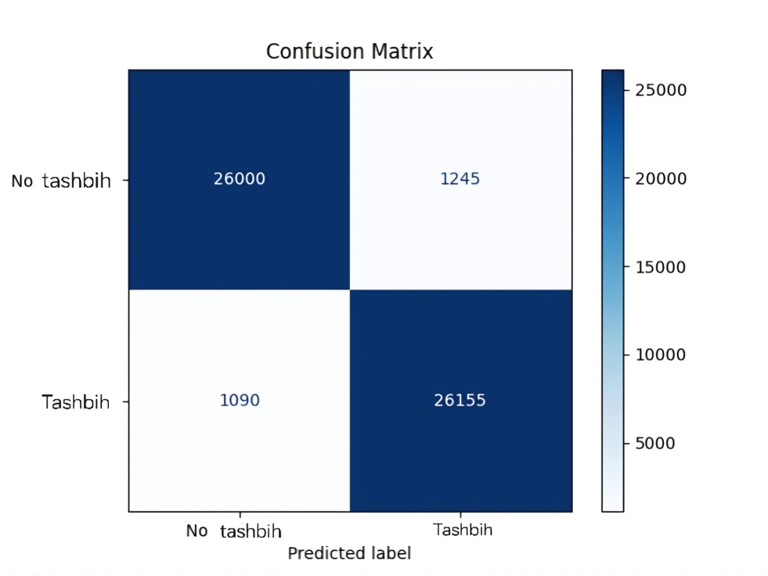
The confusion matrix confirms the model's balanced ability to capture both classes with relatively low error rates.

Interpretation and Potential
The results confirm that AraBERT and similar transformer models are capable of learning complex semantic patterns in Arabic poetry. Even though the current dataset consists mostly of explicit tashbīh (with visible markers such as كأن, مثل), the model's success in capturing these patterns provides strong evidence that it understands rhetorical context rather than relying solely on keyword spotting.
This outcome suggests that such models can potentially be extended and fine-tuned further to identify implicit tashbīh — where no clear simile particle exists — by learning more abstract patterns of simile. These results form a solid baseline and motivate the next stage of the thesis: focusing on generating, labeling, and detecting implicit similes.

- Planned Research and Future Work
While the initial results demonstrate strong performance in detecting explicit tashbīh, the ultimate objective of this research is to extend this capability to implicit tashbīh—those similes that lack overt comparative markers and rely on deeper semantic or contextual inference.
To achieve the overarching aim and to answer the specific research questions, the research will include the following tasks:
- Construct a labeled dataset of Arabic poems containing both explicit and implicit tashbīhs, based on an initial rule-based classifier and manual verification.
- Manual Transformation:
A curated set of poems with explicit tashbīh will be manually rewritten to remove the simile marker (e.g., "كأن", "مثل") while preserving the core meaning and rhetorical structure. This will simulate how a poet might express a simile implicitly.
- Rule-Based and Semi-Automatic Transformation:
Exploratory methods will be developed to automatically remove simile markers from known tashbīh lines, creating a larger set of implicit-style examples for training.
- Building a New Dataset:
The transformed implicit tashbīh lines will be labeled and verified by Arabic language experts. A balanced dataset will be constructed containing explicit tashbīh, implicit tashbīh, and non-tashbīh lines.
- Fine-tune transformer-based Arabic language models (e.g., AraBERT) to distinguish poems with tashbīh from those without, using both explicit and implicit instances.
- Design a transformation framework to manually or semi-automatically convert explicit tashbīh examples into implicit ones by removing or hiding the comparison marker while preserving semantic meaning and poetic structure.
- Develop a classification model capable of identifying implicit tashbīh based on semantic features, syntactic context, and poetic discourse patterns.
- Developing Enhanced Detection Models:
AraBERT or similar language models will be fine-tuned on the newly constructed dataset. Feature engineering will also be applied to enhance detection, such as sentence structure, syntactic trees, or rhetorical embeddings.
- Evaluate the models’ performance using standard metrics (accuracy, precision, recall, F1-score), alongside qualitative analysis of correctly and incorrectly classified examples.
- Evaluation and Benchmarking:
The model will be evaluated using accuracy, precision, recall, and confusion matrices. Qualitative analysis will also be conducted to interpret model decisions, particularly in ambiguous or misclassified cases
- Contribution
This research aims to make significant contributions to the intersection of Arabic linguistics, digital humanities, and natural language processing. By focusing on the detection of both explicit and implicit tashbīhs in classical Arabic poetry, this work bridges centuries-old rhetorical theory with modern AI tools. Moreover, the methodologies and models developed in this study hold the potential to be adapted for analyzing rhetorical patterns in other literary traditions, such as Hebrew and English, thereby opening the door to cross-linguistic and comparative literary research using NLP.

Linguistic and Theoretical Contributions
- Modeling implicit Rhetoric: The thesis explores and formalizes the concept of tashbīh muʾakkad (implicit simile) in computational terms—an area that has received very limited attention in Arabic NLP or literary analysis.
- Dataset Curation: It introduces a novel dataset of Arabic poetry annotated for both explicit and implicit similes, offering a resource that can support future research in figurative language processing for Arabic.
- Augmentation of Classical Theory: Through the transformation of explicit into implicit tashbīh, this work contributes to the study of Arabic balāgha by demonstrating new rhetorical equivalencies grounded in semantic preservation.

Technical and Computational Contributions
- Pipeline for tashbīh Detection:
The research presents a hybrid methodology that combines rule-based techniques with deep learning models (e.g., AraBERT) to achieve high-accuracy classification of poetic verses.
- Benchmarking NLP Models on Arabic Poetry:
It evaluates the performance of transformer-based models on a uniquely complex domain—classical Arabic poetry—which is morphologically rich and syntactically free-form.
- Demonstrating Semantic Learning:
By achieving high accuracy even on a small training subset, the model shows that transformer models can meaningfully capture rhetorical intent in Arabic, setting the foundation for detecting deeper forms of metaphor and simile.
- Open-Source Codebase and Tools:
The work includes clean, reusable Python code (available on GitHub) for processing, training, and evaluating Arabic poetry classification tasks—serving the community and future researchers.

- References
- Ryding, K. C. (2005). A Reference Grammar of Modern Standard Arabic. Cambridge University Press.
- Abdul-Raof, H. (2006). Arabic Rhetoric: A Pragmatic Analysis. Routledge.
- Habash, N. Y. (2010). Introduction to Arabic Natural Language Processing. Morgan & Claypool Publishers.
- Ferguson, C. A. (1959). Diglossia. Word, 15(2), 325–340.
- Albirini, A. (2016). Modern Arabic Sociolinguistics: Diglossia, Variation, Codeswitching, Attitudes and Identity. Routledge.
- Al-Saqqaf, A., & Al-Ayyoub, M. (2021). Computational Analysis of Arabic Poetry: Challenges and Perspectives. ACM Transactions on Asian and Low-Resource Language Information Processing (TALLIP), 20(4), 1–25.
- Jurafsky, D., & Martin, J. H. (2023). Speech and Language Processing (3rd ed.). Draft. Stanford University.
- Cambria, E., Schuller, B., Xia, Y., & Havasi, C. (2022). Affective Computing and Sentiment Analysis. In The Springer Handbook of Computational Intelligence (pp. 1–17). Springer.
- Vaswani, A., Shazeer, N., Parmar, N., Uszkoreit, J., Jones, L., Gomez, A. N., ... & Polosukhin, I. (2017). Attention is All You Need. In Proceedings of the 31st International Conference on Neural Information Processing Systems (NIPS 2017), pp. 5998–6008.
- Habash, N. (2010). Introduction to Arabic Natural Language Processing. Synthesis Lectures on Human Language Technologies, 3(1), 1–187. Morgan & Claypool.
- al-Hāshimī, A. (1998). Jawāhir al-Balāghah. Dar al-Kutub al-ʿIlmiyya.
- al-Jurjānī, ʿA. (1954). Asrār al-Balāgha. Istanbul.
- al-Zubaidī, M. M. (1975). Tāj al-ʿArūs. Kuwait.
- Ali, A. & Ahmad, H. (2015). Classical Arabic rhetoric. Journal of Arabic Literature.
- Antoun, W. et al. (2020). AraBERT. Workshop on Open-Source Arabic Tools.
- [Su, Y. et al. (2020). DeepMet. ACL.
- Leong, C. et al. (2020). MelBERT. EMNLP
- Boudchiche, M. et al. (2017). AlKhalil Morpho Sys 2. Journal of King Saud University.
- Pasha, A. et al. (2014). MADAMIRA. Proceedings of LREC.
- Buckwalter, T. (2002). Buckwalter Arabic Morphological Analyzer Version 1.0. Linguistic Data Consortium, University of Pennsylvania.
- Maamouri, M., Bies, A., Buckwalter, T., & Mekki, W. (2010). Standard Arabic Morphological Analyzer (SAMA) Version 3.1 (LDC2010L01). Linguistic Data Consortium.
- Abdelali, A., Darwish, K., Durrani, N., & Mubarak, H. (2016). Farasa: A fast and furious segmenter for Arabic. In Proceedings of the 2016 Conference of the North American Chapter of the Association for Computational Linguistics: Demonstrations (pp. 11–16). Association for Computational Linguistics.
- Diab, M. (2009). Second generation AMIRA tools for Arabic processing: Fast and robust tokenization, POS tagging, and base phrase chunking. In Proceedings of the 2nd International Conference on Arabic Language Resources and Tools (MEDAR), Cairo, Egypt.
- Abd Alhadi ,H., Hussein , A. A. ,&Kuflik,T.(2023). Automatic identification of rhetorical elements. Digital Humanities Quarterly.
- Hussein ,A .A. (2015). The Rhetorical Fabric of the Traditional Arabic Qaṣīda. Wiesbaden: Harrassowitz Verlag.
- Hussein et al. (2023). Limitations of REI. Digital Humanities Quarterly.
- Belinkov, Y., & Glass, J. (2019). Analysis methods in neural language processing: A survey. Transactions of the Association for Computational Linguistics, 7, 49-72.
- Ibrahim, A., & Elghazaly, T. (2013, November). Improve the automatic summarization of Arabic text depending on Rhetorical Structure Theory. In 2013 12th Mexican International Conference on Artificial Intelligence (pp. 223-227). IEEE.
- Mann, W. C., & Thompson, S. A. (1988). Rhetorical Structure Theory: Toward a functional theory of text organization. Text & Talk, 8(3), 243–281.
- Salton, G., Wong, A., & Yang, C. S. (1975). A vector space model for automatic indexing. Communications of the ACM, 18(11), 613–620.
- Khan, R. S., & Rahman, A. (2025, April). Computationally Distinguishing Quran and Pre-Islamic Arabic Poetry. In 2025 Eighth International Women in Data Science Conference at Prince Sultan University (WiDS PSU) (pp. 1-6). IEEE.

